**Amazon AWS Part One**

**Lab 1 – Introduction to AWS IAM**

**Lab 2 – Build your VPC and Launch a Web Server**

**Lab 3 – Introduction to Amazon EC2**

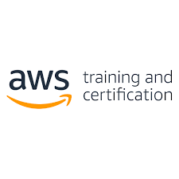

By, Liam Gilmartin.

**Purpose -** The purpose of these labs is to complete the first three introductory labs of Amazon AWS and learn their components including building your own VPC and launching a web server.

**Background Information on Lab Concepts -**

* AWS Identity and Access Management is a web service that enables AWS customers to manage permissions and users in AWS. With IAM, you can centrally manage users, security credentials, and permissions.
* Amazon Virtual Private Cloud enables you to launch AWS resources into a virtual network that you defined. This virtual network closely resembles a traditional network that you would operate in your own data center, with the benefits of using the scalable infrastructure of AWS.
* Amazon Elastic Compute Cloud is a web service that provides resizable computer capacity in the cloud, designed to make web-scale cloud computing easier for developers. Amazon EC2's simple web service interface allows you to obtain and configure capacity with minimal friction and provides you with complete control of your computing resources. Amazon EC2 reduces the time required to obtain and boot new server instances to minutes, allowing you to quickly scale capacity, both up and down, as your computing requirements change.

**Lab Summary -**

* The first lab was an introductory lab that allowed us to understand some of the simpler tasks as an AWS cisco student. Task 1 of the first lab focuses on teaching about how to change user/group settings and is primarily an overview. Task 2 of the first lab is about adding users to specific groups. You will then need to add user-1 to the S3-Support Group, user-2 to the EC2-Support Group, and user-3 to the EC2-Admin Group. The third task in this first lab will take you through signing in and testing users.
* In the second lab we used Amazon Virtual Private Cloud (VPC) to create our own VPC and add additional components to produce a customized network. We also created a security group. Then we configured and customized an EC2 instance to run a web server. Task 1 of the second lab is to create your own VPC. Task 2 of this lab walks you through creating some additional subnets and assigning them to availability zones “A” and “B.” Task 3 of this lab has you create a VPC security group and learn how to manage it.
* The third lab consisted of a basic overview of launching, resizing, managing, and monitoring an Amazon EC2 instance. The first task of the third lab was to launch your own amazon EC2 instance. You will then create names and tags for the instance and select the OS images and what else you would like to apply. Next you add an instance type, create a login, change network settings, configure storage and advanced details, then launch the instance. Task two focuses more so on simply monitoring the instance that you have just created. Task three focuses more on updating the security group and beginning to access the web server. Task 4 walks you through how to resize your instance including the type and EBS volume. Task 5 is about exploring the limits of EC2. Finally, task 6 tells you how to test termination projection.

**Lab Commands –** The first three introductory AWS labs did not contain any single commands.

**Configurations -** 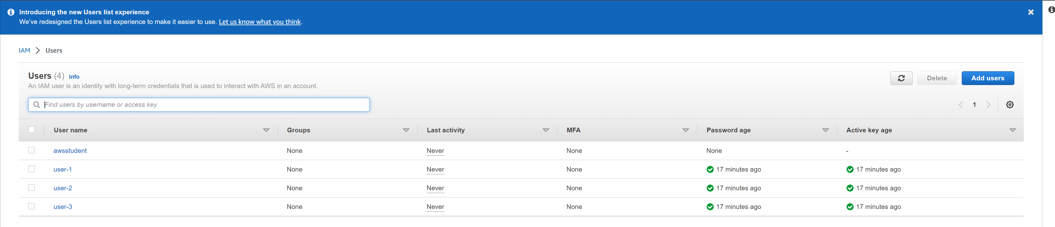Accessing users^^

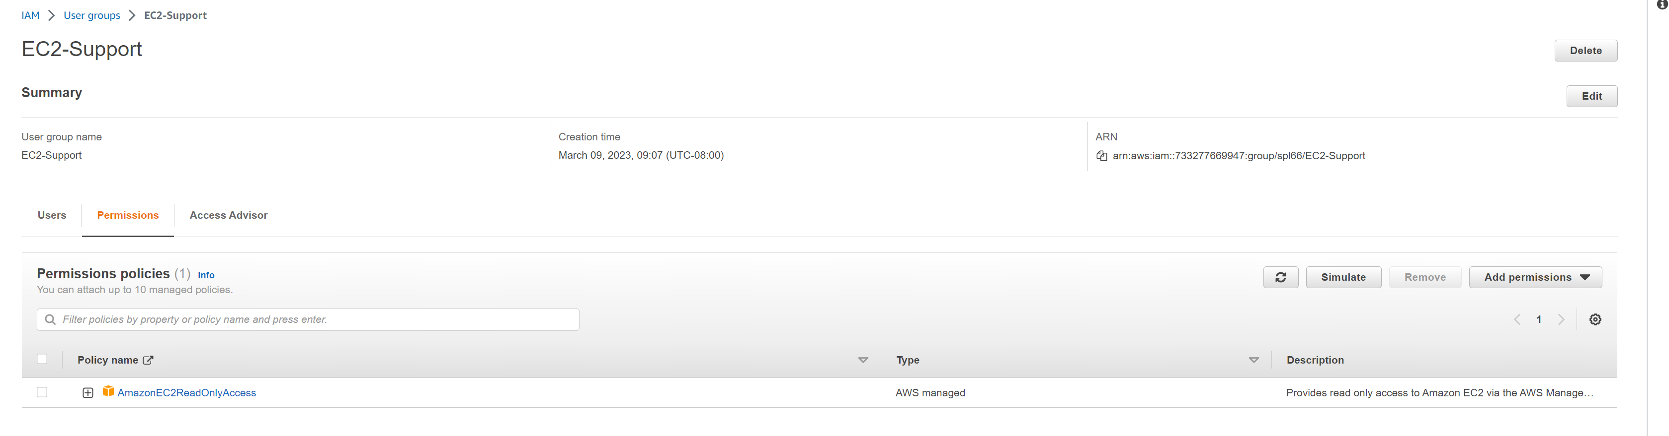

Adding users to groups^^

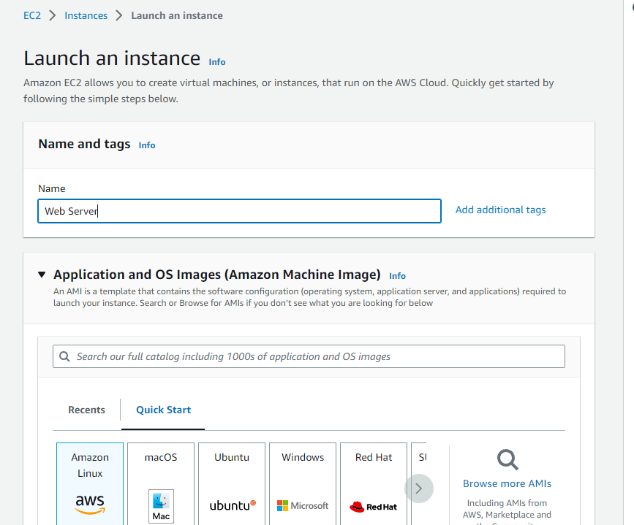

Launching AWS web server instance^^

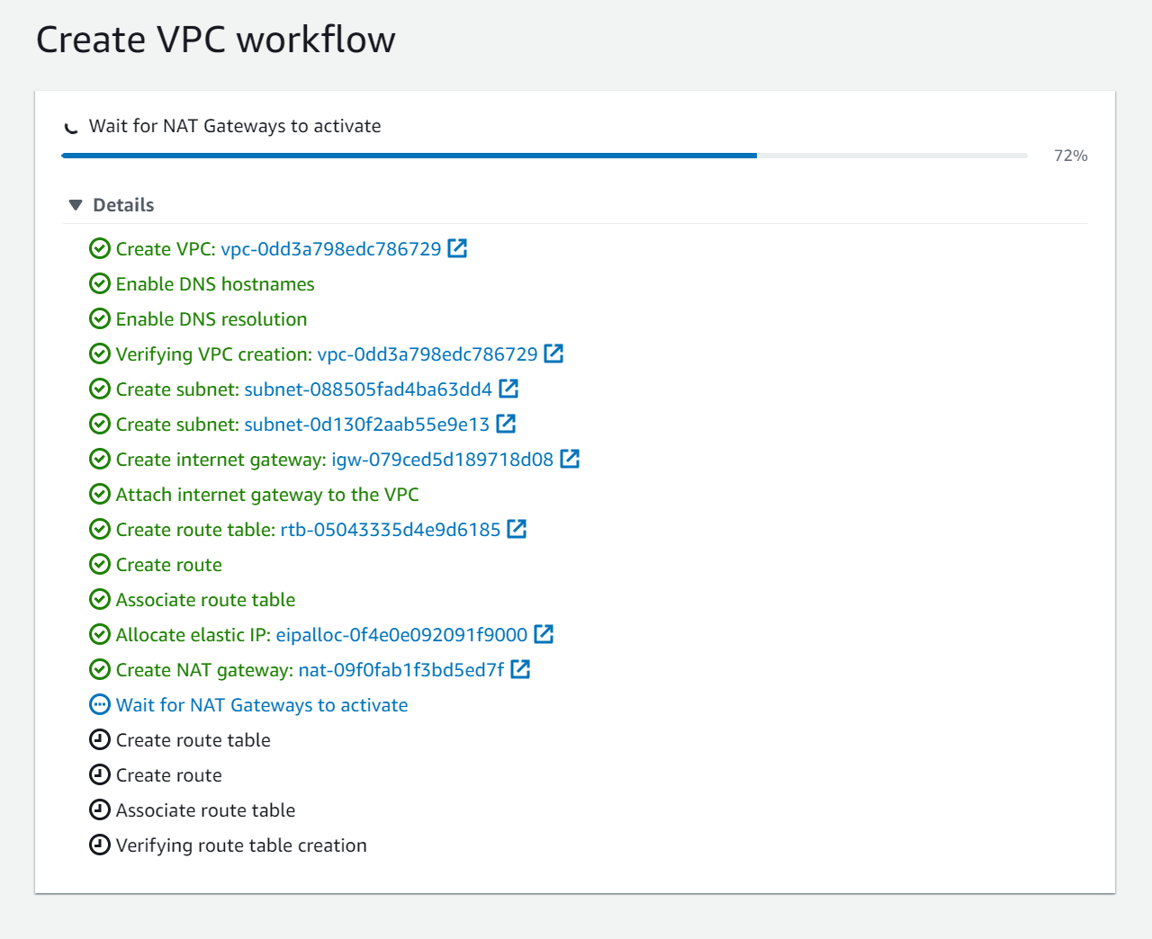

Waiting for the NAT gateways to activate^^

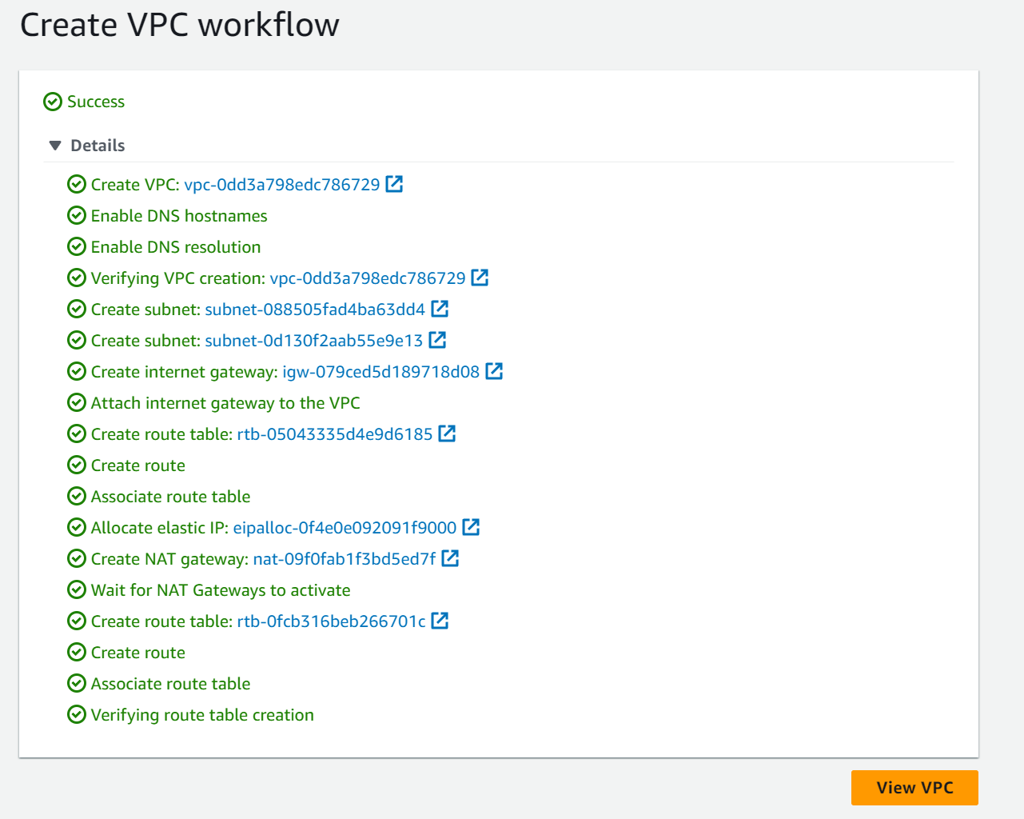

Successfully created^^

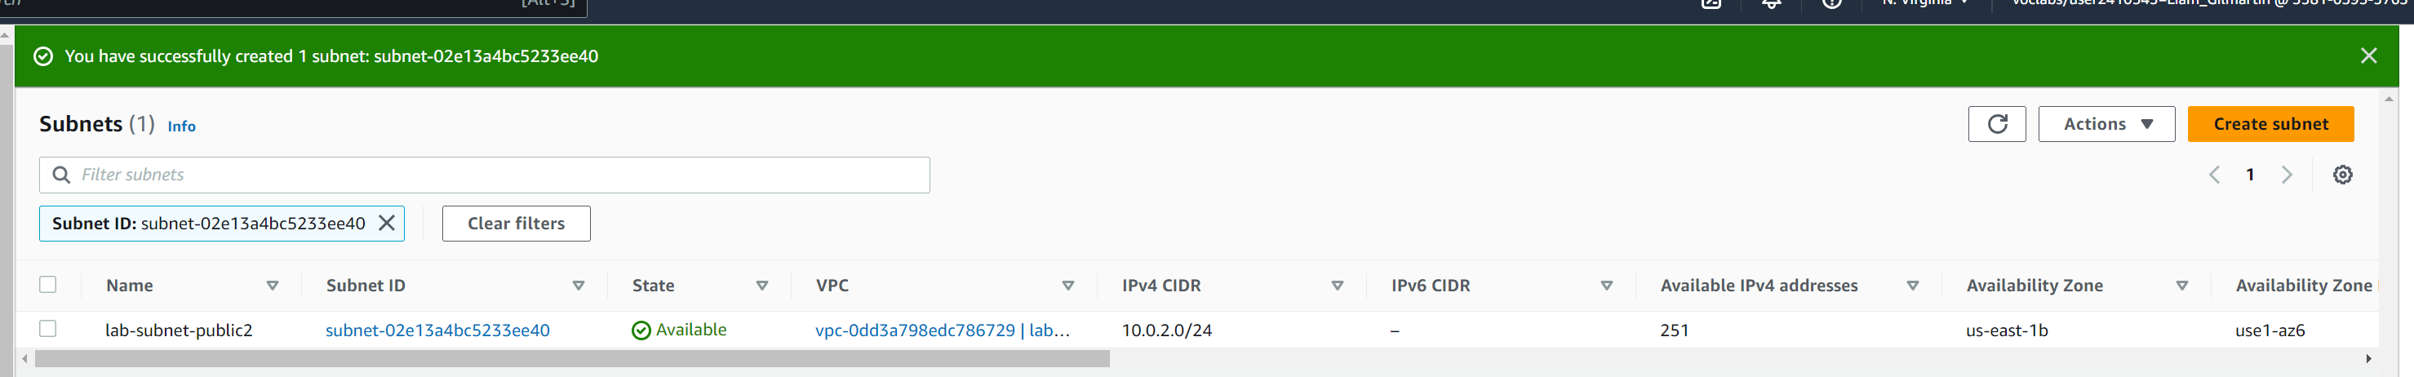

Subnet created^^

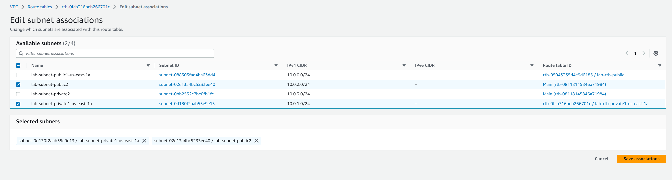

Editing subnet associations^^

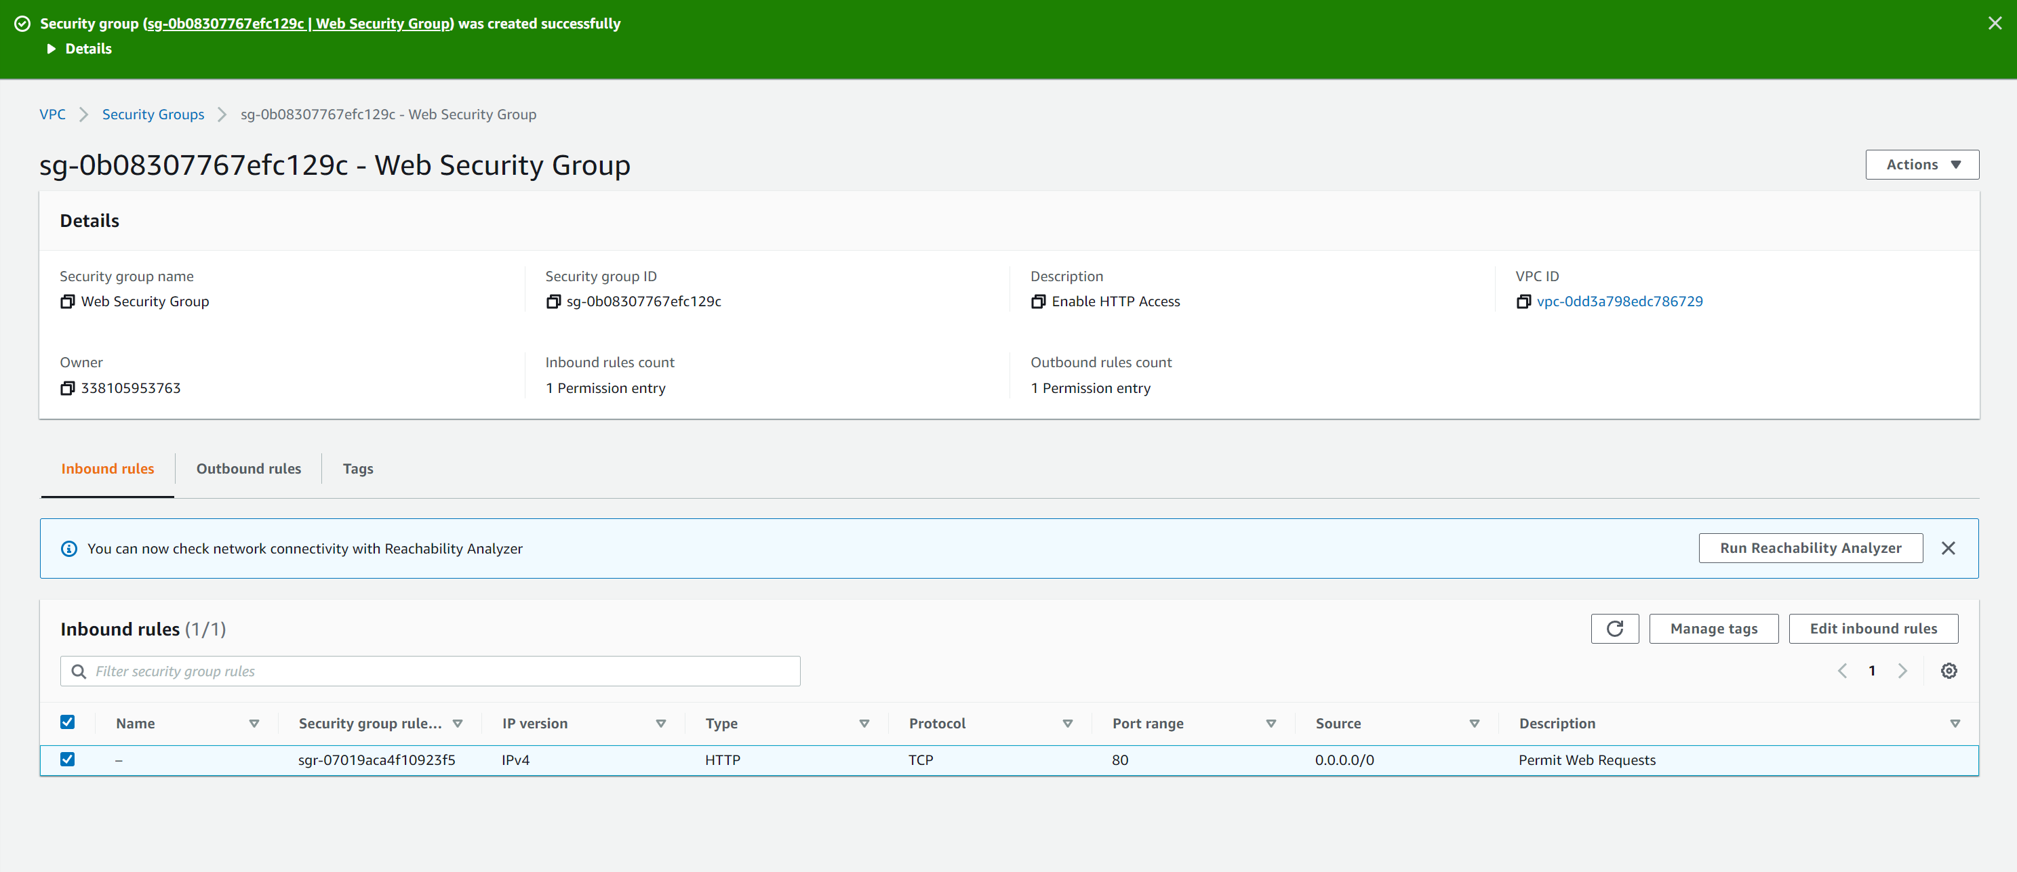

Security group successfully created^^

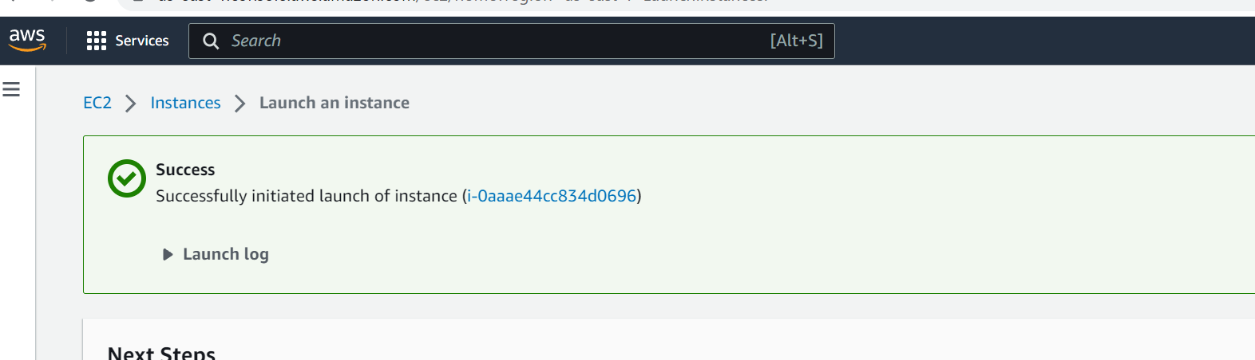

Launched the EC2 instance successfully^^

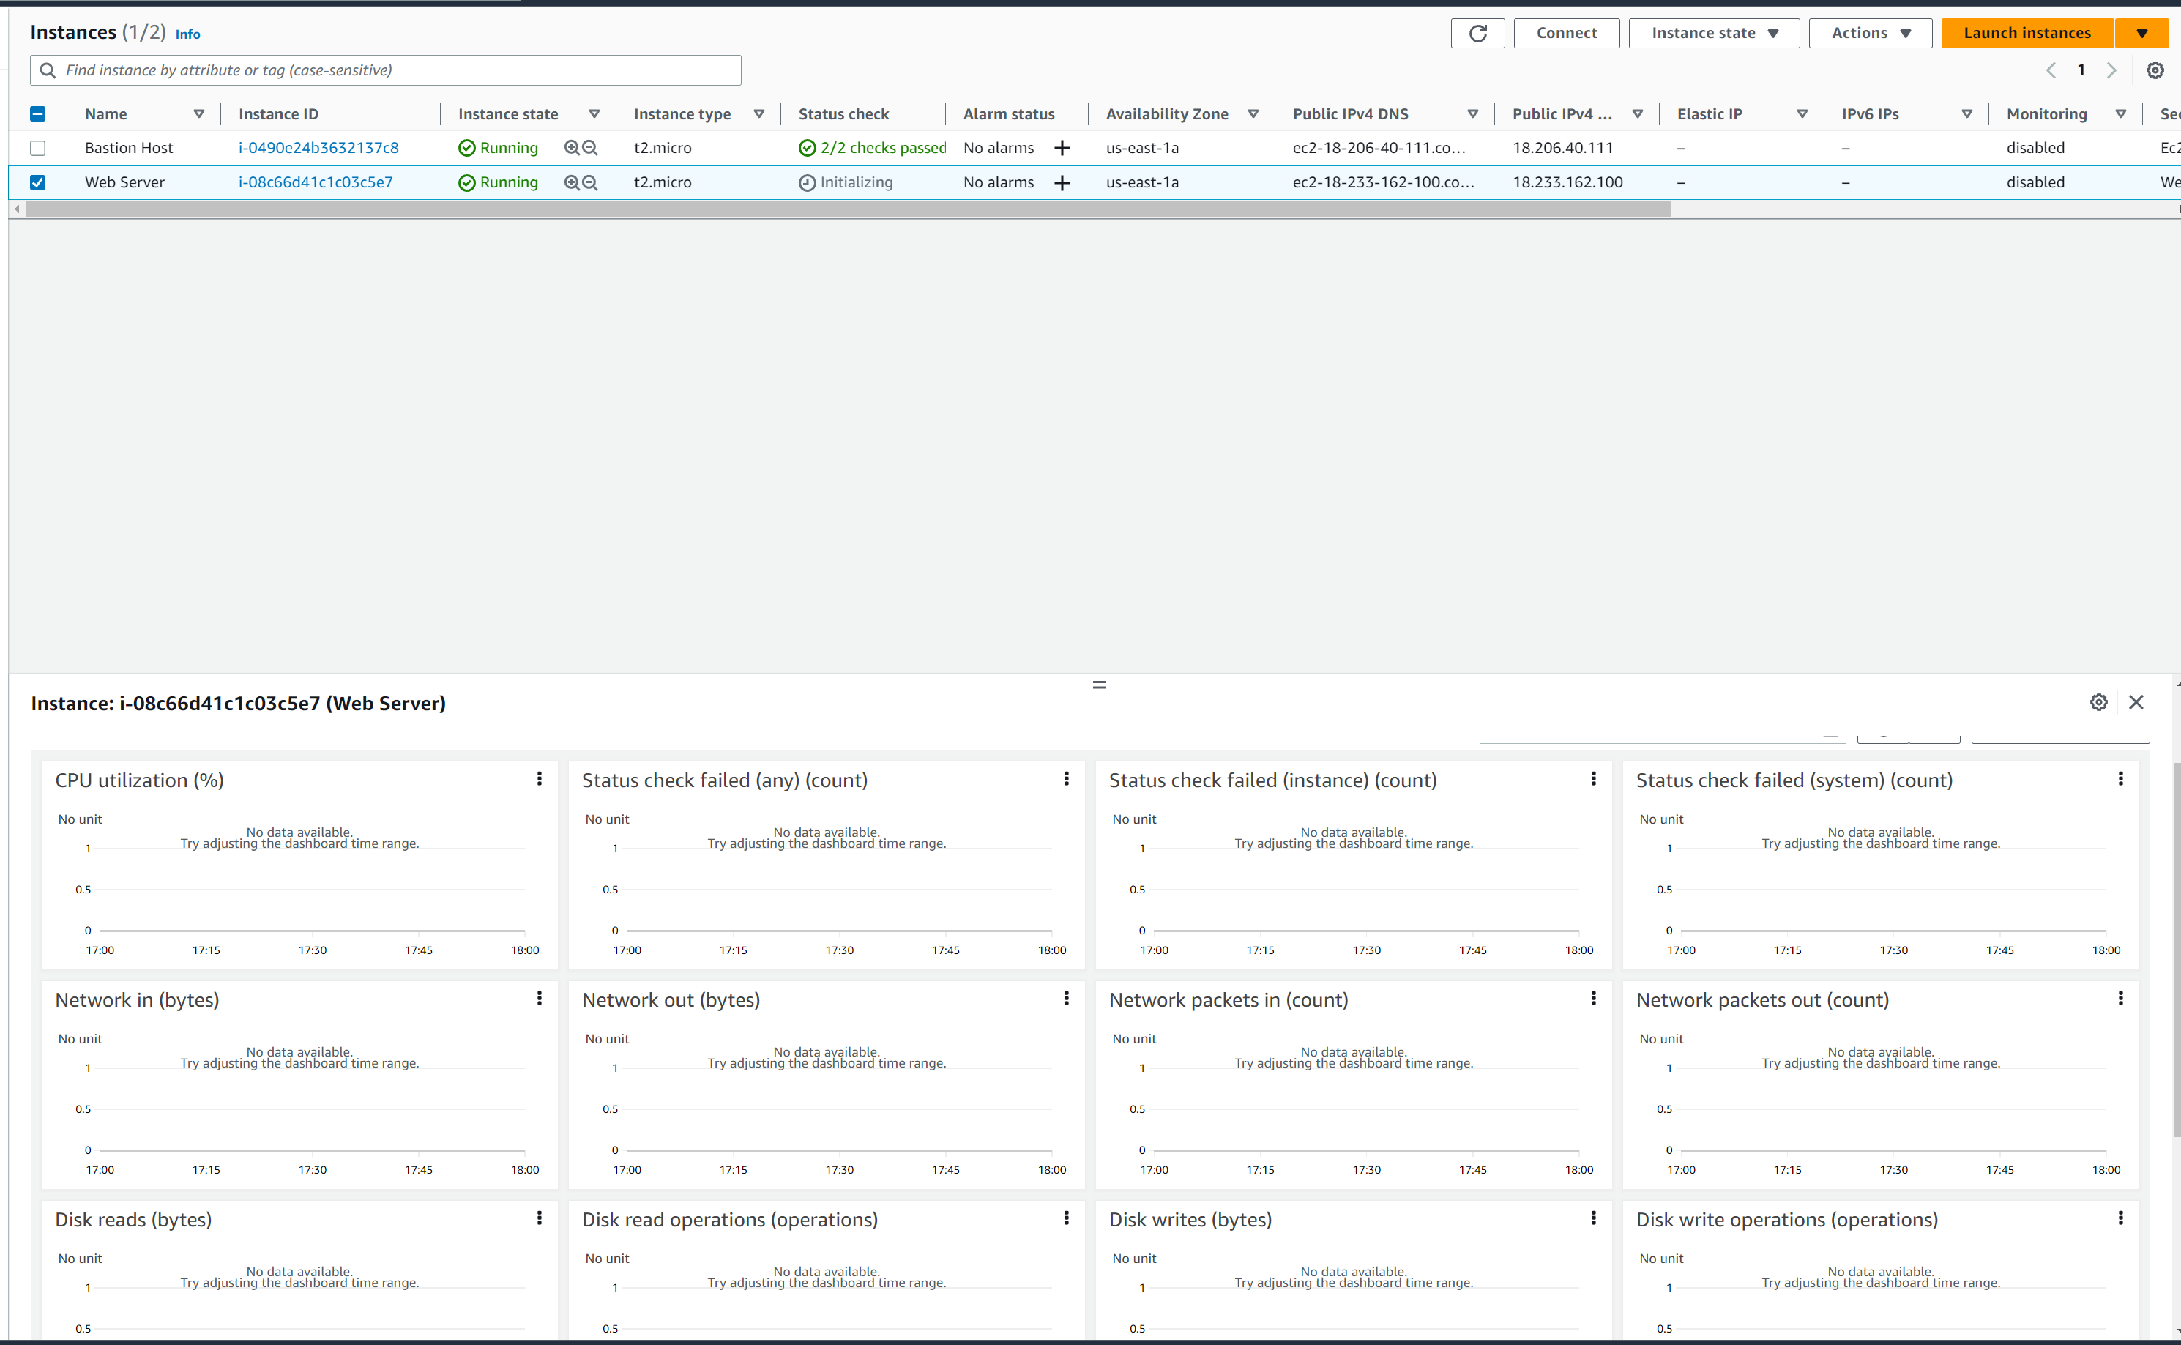

Monitoring and troubleshooting EC2 instances^^

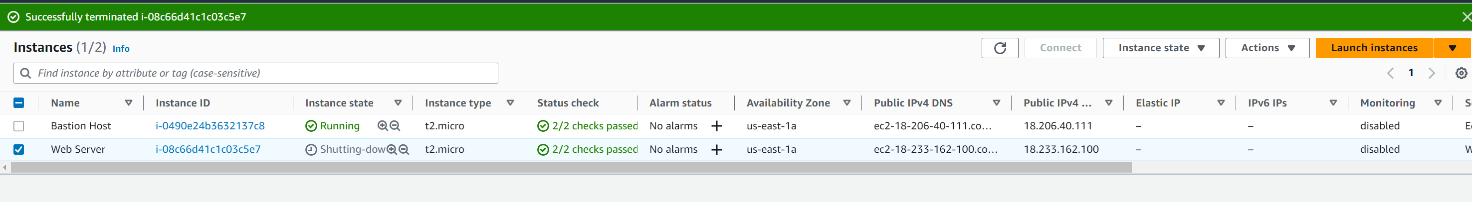

Terminating the EC2 instance^^

**Problems –** I did not end up having any problems occur during the first three labs in the AWS cloud security course.

**Conclusion -** In summary we completed the first three introductory Amazon AWS labs and learned the fundamentals of how to move our way around in the AWS program. Some of the tasks I learned how to do well completing these three labs are launching EC2 instances, creating security groups, configuring VPC’s, and much more. These three labs were very helpful and instructive lessons, overall.